Problem:
Mental fatigue and burnout from constant performance pressure as a student-athlete.
Grand Challenge:
Well-being, health, & eudaimonia
Designing an app that helps student-athletes track mental fatigue and get support before burnout hits.
Stories
As a who, I need what, so that why.
- As a student-athlete, I need a super quick way to log how mentally drained I feel so that I actually keep up with it.
- As a student-athlete, I need the app to recognize when I’m in a high-stress week (like games or travel) so that it can adjust what it asks me.
- As a student-athlete, I need reminders that don’t feel annoying so that I don’t just ignore or mute the app.
- As a student-athlete, I need a simple weekly summary of my stress and fatigue so that I can see when I’m trending toward burnout.
- As a student-athlete, I need personalized suggestions that fit my schedule so that I know small things I can do to recover.
- As a student-athlete, I need the app to feel supportive instead of judgmental so that I’m honest about how I’m actually feeling.
- As a student-athlete, I need the app to be usable on the go (bus, locker room, between classes) so that it fits into my real day.
INTERVIEW SUMMARY
Interviewee 1 – Teammate (Volleyball) Lindsey Green Junior setter (starter)
She said she feels mentally drained during game weeks, especially when there’s travel and late nights. She tries using regular wellness apps, but they feel made for “less active people,” not full time playing athletes. She said she doesn’t want long surveys—just something quick she can do after practice. She also said she usually doesn’t realize how burnt out she is until she snaps at someone or can’t focus in class. She brought up something her sports psych always says: “the first sign of burnout is when you can’t even take care of yourself, but athletes never notice it until we’re literally falling apart or someone calls us out.” She said that’s basically her every game week.
Interviewee 2 – Kendyl Thrasher Junior cross country and track indoor/outdoor
She mentioned that her stress comes in waves: preseason, midterms, and conference are the worst. She has tried journaling apps, but she forgets to use them. She said if an app could show her a pattern like “you’ve had four high-stress days in a row,” that would actually get her attention. She also said she’d want suggestions that are realistic, like “take 10 minutes to stretch” instead of “meditate for an hour.” She literally never gets a real break because she does cross country, indoor track, and outdoor track, so she’s basically in season all year. She told me she’s honestly scared burnout is going to hit her hard if she doesn’t start taking better steps to prevent it. She said it feels like she’s always “on,” and there’s never a moment to fully reset.
Interviewee 3 – Non-athlete Friend Josie Bloom Senior (education major) Ex Volleyball player (student athlete to student)
Josie used to be an athlete, and now that she’s not competing anymore she realizes how much extra time and mental space she has. She said when she was still in sports, she struggled a lot with balancing everything and didn’t really notice how mentally drained she was until she finally stepped away. Now she wishes there was a way for athletes who are still in it to recognize that mental fatigue earlier, because she only got better once she quit and actually had time to take care of herself. She said she gets stressed too, but her schedule is more predictable. She uses a mood tracker sometimes, but it doesn’t connect to her school workload. She said she thinks athletes have it worse because they’re juggling way more time-sensitive stuff. She said she loves the idea of an app that actually changes based on game weeks or travel days.

Patterns
- People don’t want long, complicated check-ins.
- They want the app to notice patterns (like multiple high-stress days).
- They want suggestions that are realistic and not cheesy.
- Athletes feel like normal wellness apps don’t “get” their schedule or pressure. (Josie – athlete to student) highlighted this
- What is normal to athletes causes blindness to mental issues until completely out of sport, break, and or someone confronts them.

Overall, the interviews showed that student-athletes want something quick, simple, and actually tailored to their lifestyle. They don’t want another generic wellness app—they want something that understands game weeks, travel, and the constant pressure to perform.

Stories/interview info – Sketches
- Going wide / considering multiple options
Going Wide. Early rough sketches exploring different possible interactions for the app, including check-ins, weekly summaries, suggestions, and special modes like game week or travel.

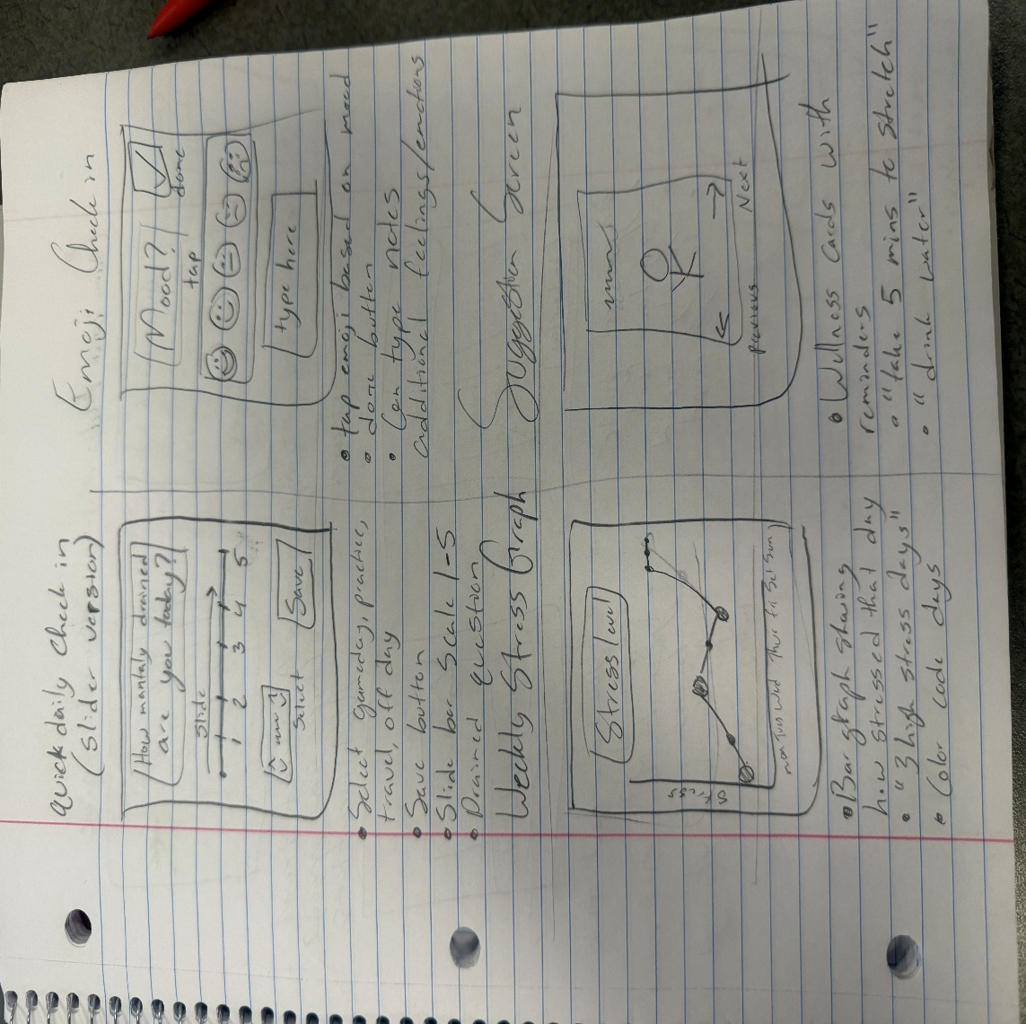

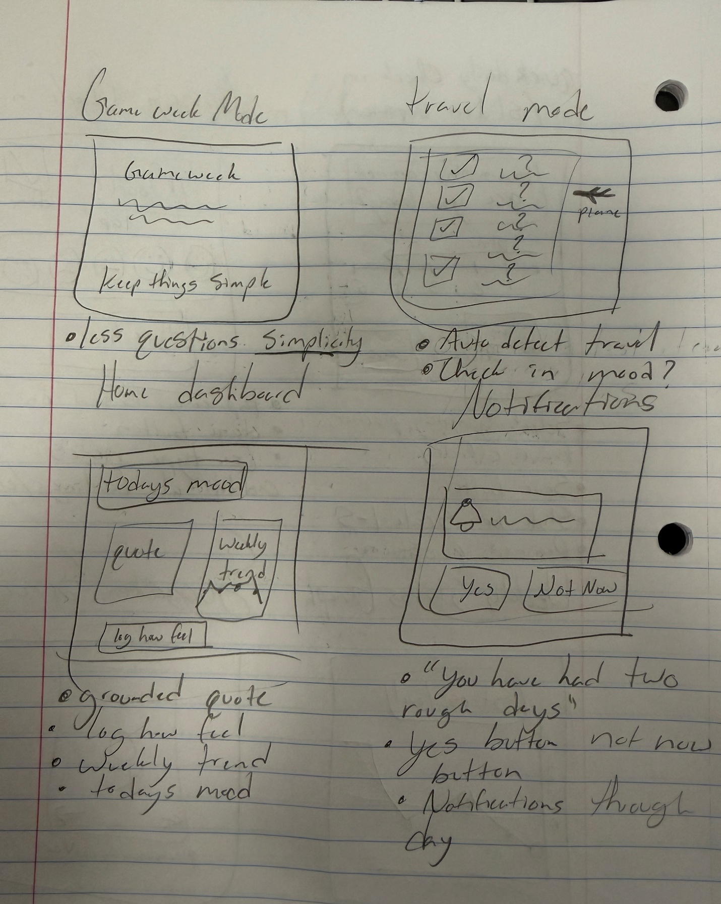

- Drilling down / refining a specific workflow ( take one of your options and design 2-3 variations of it, play with how it works )
Variation A - A Three-screen version of the workflow using a slider check-in, a weekly stress graph, and a suggestions list.
Variation B - A simplified workflow using emoji-based mood logging, a short daily summary, and a single suggestion card.
Variation C - A compact design combining mood logging, context tags, weekly trends, and suggestions all on one screen for fast,
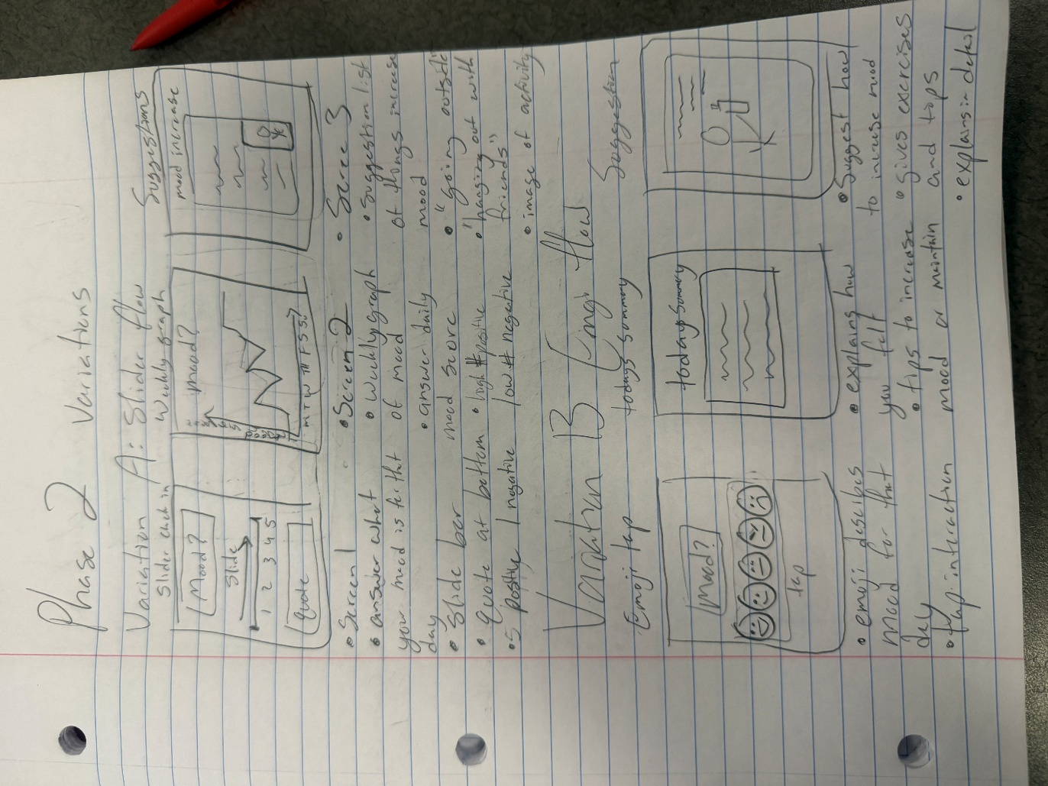

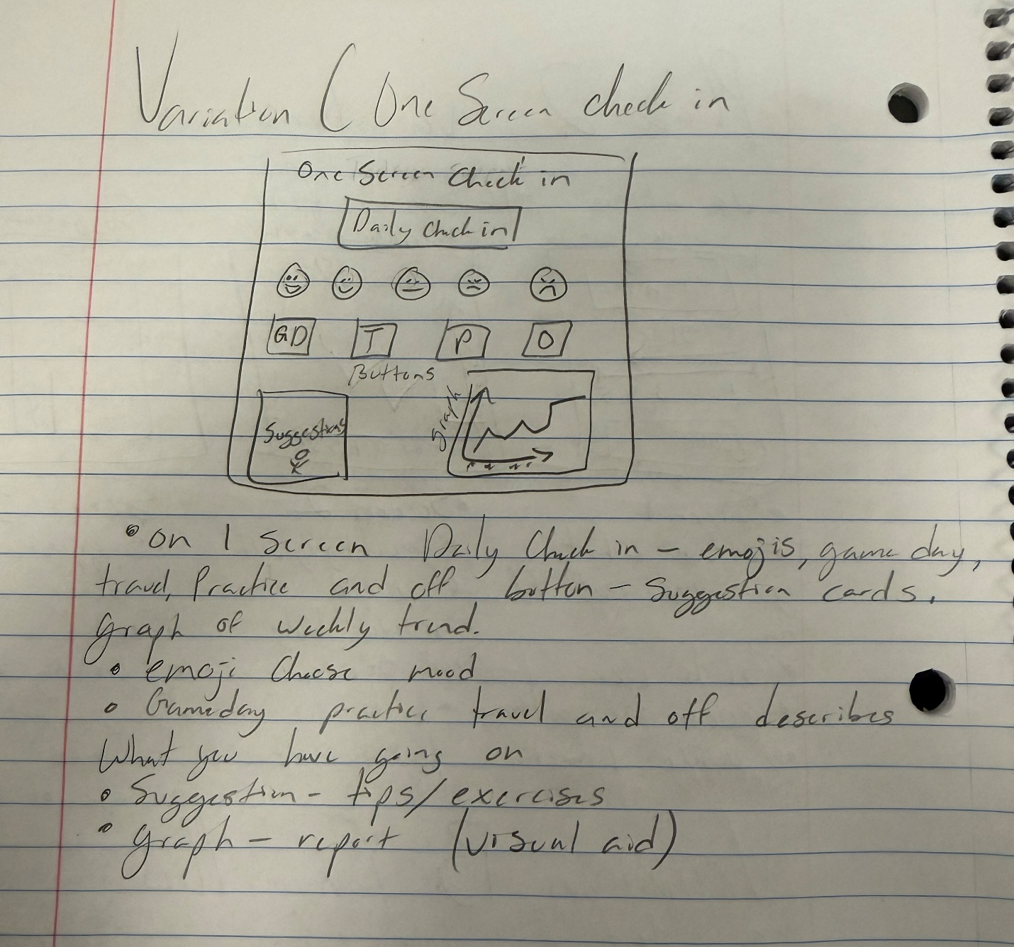

- A finished, refined workflow from your selected explorations in step 2. This series of sketches should be more refined with easier to identify shapes and headings, legible written documentation of each step.
Screen 1 - A clean, refined version of the check-in screen using a slider and context tags to support quick, on-the-go logging.
Screen 2 - A clean weekly overview showing stress patterns and highlighting high-stress streaks to help athletes recognize burnout early.
Screen 3 - The final suggestions screen offering realistic, supportive recovery ideas based on the user’s check-in and weekly trends.
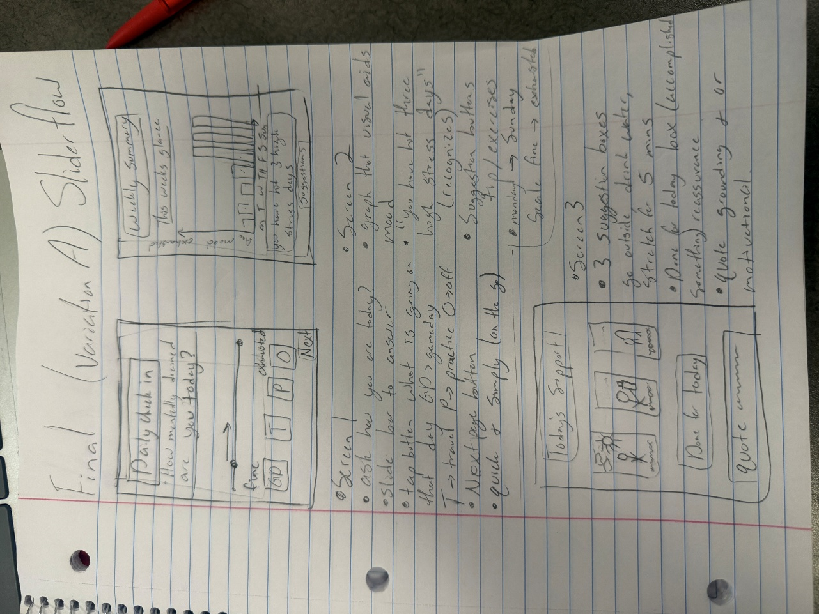
Overall, the final refined sketch directly supports the needs identified in my one-sentence stories and the patterns from my interviews. The design focuses on a quick daily check-in, a simple weekly summary, and realistic suggestions that fit a student-athlete’s schedule. Each screen is meant to be fast, supportive, and easy to use on the go, which matches what every interviewee said they needed. The final version reflects the most important themes: avoiding long or overwhelming tasks, recognizing burnout patterns early, and giving athletes small, doable steps to take care of themselves before things get worse

